**Dashboard**





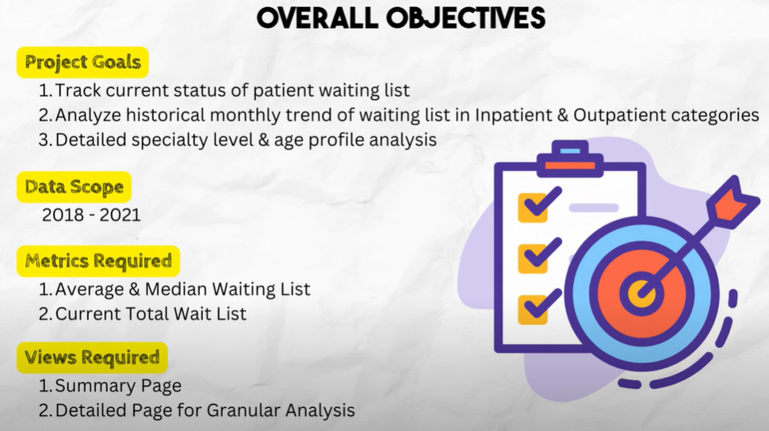

Data =Inpatient ,Outpatient two files

**Data collection** :

Import folder load the data inpatient and outpatient (combing and load )

Data Transformation and modeling

Make sure outpatient and inpatient column should match

Append both inpatient and outpatient as new column ALL_Data (Append Quieres as New )

Now we have 3 models view

Inpatient

Out patient

All Data

Set the realtion between the all data and Mapping speciality

Data modeling done some connection



Latest month wait list

Previous month wait list

Py lastest month list  =CALCULATE(sum(All_Data[Total]),All_Data[Archive_Date]=EDATE(MAX(All_Data[Archive_Date]),-12))